Daschbach Dentistry

Formal business, technical requirements and specifications document

# Contents

Contents 1

Contact 2

Client 2

Developer 2

Website 2

Overview 4

Purpose of this Document 4

Summary 4

Service(s) Requested 5

Page by Page Review of Demo Website 6

General 6

Navigation Bar 7

Footer 10

Landing Page 11

Services 14

Meet the Doctors 17

Mission Statement 19

New Patient Forms 20

Photo Gallery 21

Our Staff 24

Contact 26

Careers 29

Reporting Issues 30

Taiga 30

Load Times 30

Developer Notes 31

Technologies Used 31

Website Structure 31

Running Locally 31

Document History 31

# Contact

Last Update: 12/16/2015

## Client

|  |  |
| --- | --- |
| Company Formal Name | Daschbach Family Dentistry, LLC |
| Locally Known As | Daschbach Dentistry |
| Company Address |  |
| Name of Project Owner | Linsey Grey |
| Phone Number of Project Owner |  |
| Email of Project Owner | Linseygrey20@gmail.com |
| Company Phone Contact for Public Use |  |
| Company Phone Contact for Communication Between Developer and Client |  |
| Company Email Contact  for Communication Between Developer and Client |  |

Approved by:_________________________

Approval date: ________________________

## Developer

|  |  |
| --- | --- |
| Developer Name | Ryan Piveteau |
| Living Address | 141 Levering Street Philadelphia PA 19127 |
| Phone Contact for Business Communication | 610 906 4133 |
| Email Contact for Business Communication | ryanpiveteau@gmail.com |
| Personal Website | ryanpiv.github.io/welcome |

Approved by: Ryan Piveteau_____________

Approval date: 12/16/2015______________

## Website

|  |  |
| --- | --- |
| Demo / QA Website Host URL | https://www.gearhost.com/ |
| Demo/ QA Website URL | http://daschbachdentistry.gear.host/ |
| Demo/ QA FTP URL | ftp.gear.host |
| Demo/ QA FTP Username | daschbachdentistry\$daschbachdentistry |
| Demo/ QA FTP Pass | dpSDxGllXliaNhXMBYifLySAk6yqPgdKPbMxb1WDYZ0l58DqvQW4ZRHSCqhE |
| Production / Live Website URL | http://www.daschbachdentistry.com/ |
| Production FTP URL |  |
| Production FTP Username |  |
| Production FTP Pass |  |
| Other Domain Names Owned |  |
| Source Control Platform | Github |
| Source Control URL | https://github.com/ryanpiv/Daschbach-Dentistry |
| Bug Reporting System | Taiga |
| Bug Reporting URL | https://tree.taiga.io |
| Bug Reporting System Admin Name | Ryan Piveteau |
| Bug Reporting System Admin Email Contact | ryanpiveteau@gmail.com |

Approved by: Ryan Piveteau_____________

Approval date: 12/16/2015______________

# Overview

Last Updated: 12/16/2015

This document is best viewed in Microsoft Word. The document was written using built-in navigation headers. To take advantage of this feature, enable the Navigation Pane under the View menu.

## Purpose of this Document

This specific document provides clear understanding between the individual parties involved in the website’s goals. It will provide agreement to work being done and reduce repetitiveness or overhead due to misunderstandings.

Some fields are included to provide history of document updates and for client input.

Last Updated: 12/16/2015

Each section will contain a field with a date on the last time this document was updated. This is intended to be updated only by the owner of the document and not by the client, unless the document owner specifies.

It is important for the client to comment and provide their input and approval on work being done. Each section will contain two areas which allow for client input.

### Client Approval

#### Reviewer Name:

#### Latest Review Date:

These fields provide clear designation that the section has been read and approved. No history is necessary, simply update the name and date for each reviewed session.

It is expected that each time a review has been accomplished, these fields are updated. It is not necessary to update these fields when referencing the document, only when it is reviewed. If a review has been accomplished and there are no new results, it is not necessary to update the fields.

The following client input table will be found in each section where input is expected:

### Client Notes

|  |  |
| --- | --- |
| Review #: |  |
| Reviewer Date: |  |
| Review Name: |  |
| Reviewer Comments: |  |

These tables will provide history of comments for clear work requirements and help in reducing confusion on past requirements, therefore reducing overhead and duplicate work during development. It also allows the client to be clear in their desire and in what is expected to be accomplished.

This table does not need to be filled in when there are no comments or the review does not yield any new results.

## Summary

The current website at the URL (<http://www.daschbachdentistry.com/> ) is in need of reconstruction. The intention is to remove the current files on the web server and replace them with new ones. Old files will be kept as backup. All current domain name information will be kept the same, including domain name and top level domain information. Current hosting will be considered in the move to the new website.

The website development will be approached using flat design standards from a mobile first perspective. This ensures the website to function properly on all devices while keeping a consistent format of color and schema of object orientation across all platforms of devices attempting to view the website.

## Service(s) Requested

* Advice on website design
* Advice on technologies needed for redesign
* Advice on modern design standards
* Advice on server ownership
* Advice on domain ownership
* Advice on company logo
* Demonstration of website design vision
* New development of website
* New provision of formal company email addresses using the @daschbachdentistry.com predicate
* New implementation and development of content management system
* New implementation of responsive device resizing catering to smaller screen sizes
* New design architecture following Material Design standards
  1. Most patterns will be followed when possible. A combination between Bootstrap and MD will be used during development
  2. Material Design documentation can be found at:
     1. <https://www.google.com/design/spec/material-design/introduction.html>
  3. Bootstrap resources can be found at:
     1. <http://getbootstrap.com/components/>

# Page by Page Review of Demo Website

The demonstration website can be accessed by the provided URL:

* http://daschbachdentistry.gear.host/

All features shown in this website are under review and should not be considered as final.

## General

Information shown in this section is applicable to all parts of the website. It may be accessed during any part of the navigation process.

### Key Terms

This section is provided to serve as a general use to whomever may be reading and require additional information about the terms used. It is important to briefly read this section before continuing on to prohibit confusion. If terms are not understood, this section should be referenced first to serve as a FAQ.

**Responsiveness**: The website, or specific features of the website, may be referred to as responsive. This means the specific being referenced has the ability to change depending on the screen size of the device accessing it. The main factor causing the website to change is the width of the screen accessing the website.

**Navigation (nav) Bar:** The navigation (nav) bar allows for users to access different parts of the website. It can always be seen at the top of any web page.

## Navigation Bar

Last Updated: 12/16/2015

The navigation bar allows for users to access different parts of the website. It will always be present at the top of the page. This bar is programmed to be responsive to the device accessing it.

### Responsive Viewing

The navigation bar will appear as follows in browsers with a screen width greater than 1,280 pixel density:



For devices with screen widths smaller than 1,280 pixels, the navigation bar will appear as follows:



The icons have shifted to be included in the ‘hamburger’ icon to the right. The symbol is described as a hamburger by the web design industry and should be referred to as such. It is described this way as that is how it appears.

The hamburger icon expands the navigation list when clicked. A click action is the same as a touch on touchscreen devices and works in the same manner. When clicked or touched, the list appears as follows:

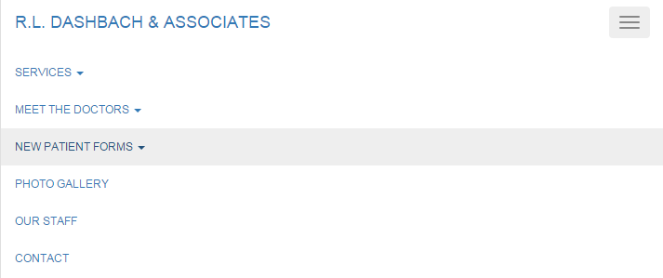

Highlighting allows for users to find which element they have scrolled over to ease of access. This is also shown in the screenshot above.

Lists may be further expanded when expansion is available. Expansion is dedicated by the upside down caret symbol.

### Summary of Links Provided

A list containing the text in the nav bar is shown below, along with its associated URLs. The associated URLS depict where the user will move to on the website when a link is clicked.

* R.L. Daschbach & Associates (http://daschbachdentistry.gear.host/index.php)
* Services
  + Currently, all services links in this list point to the URL below for ‘Services’
    - http://daschbachdentistry.gear.host/services.php
  + View All Services
  + Periodontal Services
  + Restorative Services
  + Prosthetic Services
  + Veneer & Cosmetic Services
  + Dental Implant Therapy
  + Pediatrics and Prevention
  + Financial and Insurance
* Meet the Doctors
  + Meet the Doctors
    - http://daschbachdentistry.gear.host/meet_the_doctors.php
  + Mission Statement
    - http://daschbachdentistry.gear.host/mission_statement.php
* New Patient Forms
  + The following four links do not move a user. Instead, they show a pop-up containing the associated .PDF document.
  + Hippa Form One
  + Hippa Form Two
  + Medical History Form
  + Surgical Form
* Photo Gallery
  + http://daschbachdentistry.gear.host/photo_gallery.php
* Out Staff
  + http://daschbachdentistry.gear.host/our_staff.php
* Contact
  + http://daschbachdentistry.gear.host/contact.php
* Careers
  + **( NOT YET IMPLEMENTED IN DEMO )**
  + Intended URL: http://daschbachdentistry.gear.host/careers.php
* Admin Console
  + **( NOT YET IMPLEMENTED IN DEMO )**
  + Intended URL: <http://daschbachdentistry.gear.host/admin.php>

### Client Approval

#### Reviewer Name:

#### Latest Review Date:

### Client Notes

|  |  |
| --- | --- |
| Review #: |  |
| Reviewer Date: |  |
| Review Name: |  |
| Reviewer Comments: |  |

## Footer

Last Updated: 12/16/2015

A footer is always present at the bottom of the page. The footer is responsive and will adapt to the browser’s width.



### Client Approval

#### Reviewer Name:

#### Latest Review Date:

### Client Notes

|  |  |
| --- | --- |
| Review #: |  |
| Reviewer Date: |  |
| Review Name: |  |
| Reviewer Comments: |  |

## Landing Page

Last Updated: 12/16/2015

* http://daschbachdentistry.gear.host/index.php
* http://daschbachdentistry.gear.host

Upon navigating to the demo URL, users are greeted by the landing page. This page may be accessed through the navigation bar link ‘R.L. Daschbach & Associates.’

### Desktop View

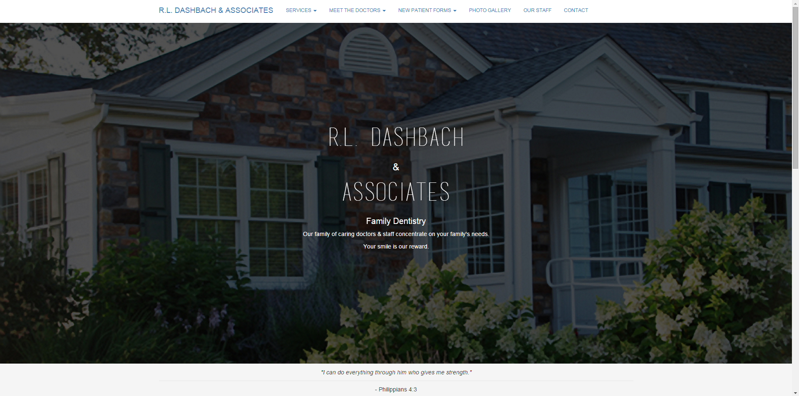

### Responsive View

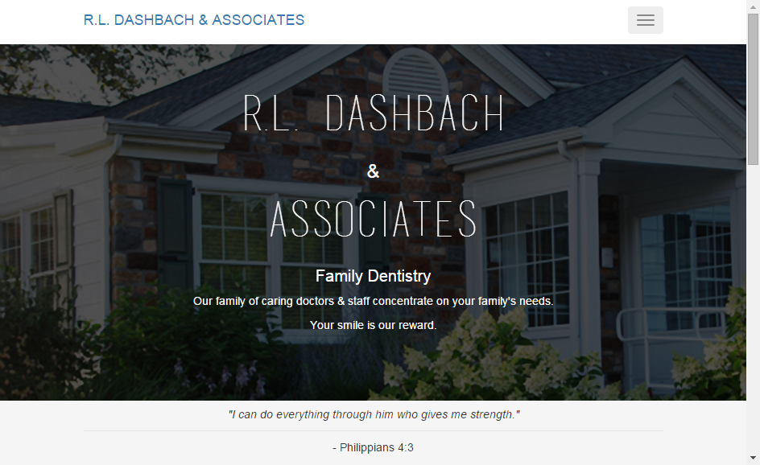

### Business Justification

The landing page is designed to provide users with an experience which is pleasing to the eye. This page must also represent the business well as it will serve as the first impression upon the user when first accessing the website.

This page may also contain a news feed of information to allow users to capture the newest improvements to the business in a manner which is important to them. It should be easily legible and compliant with most ADA standards due to the variety of patients accessing the website.

The news feed is currently composed of a slideshow and additional text. This is only shown for demo purposes and is not intended to be considered as final. The newsfeed is intended to be implemented after the website has launched for the sake of necessary requirements.

### Technical Detail

This page expands to one hundred percent of the browser’s width and height. It is responsive and will change to adapt to the browser’s current size.

The text in the middle of the page will always be centered.

### Client Approval

#### Reviewer Name:

#### Latest Review Date:

### Client Notes

|  |  |
| --- | --- |
| Review #: |  |
| Reviewer Date: |  |
| Review Name: |  |
| Reviewer Comments: |  |

## Services

Last Updated: 12/16/2015

The services page can be accessed by clicking the Services menu in the navigation bar and selecting any service. All links under the Services menu point to the URL listed below:

* http://daschbachdentistry.gear.host/services.php

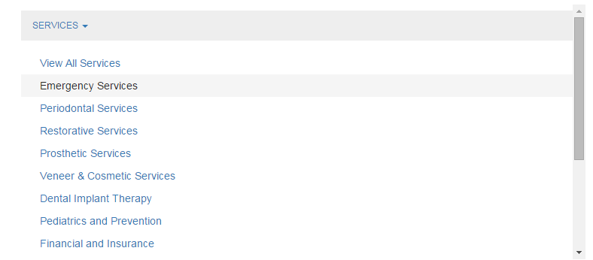

### Desktop View

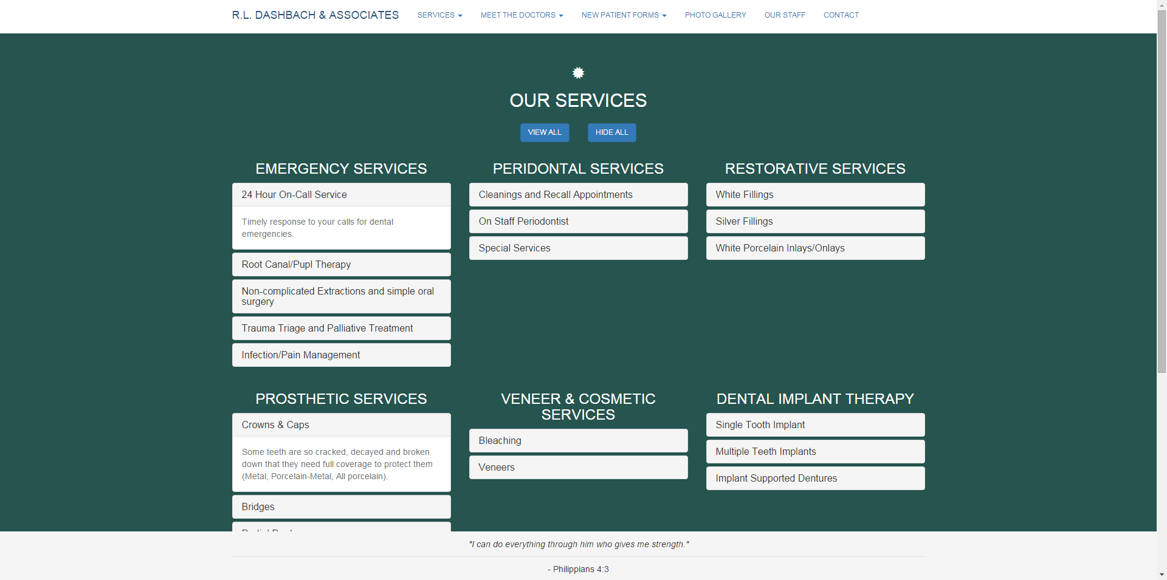

### Responsive View

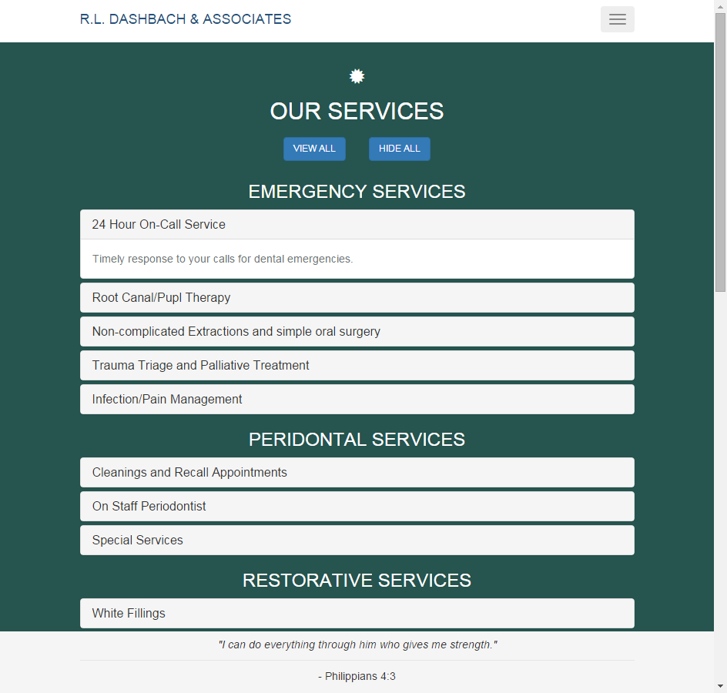

### Business Justification

The Services page provides a list of all available services to patients.

The services are organized through their respective sub sections. Each service should include short descriptions in the titles and details about the services in the description. Title and description information have yet to be clarified.

### Technical Detail

All services are shown in expandable lists. The ability to expand all lists or hide all lists exists via the use of two buttons with the text ‘View All’ and ‘Hide All’.

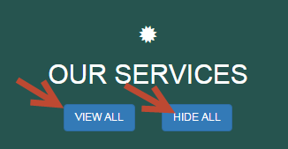

Services are expanded by clicking their titles, allow details to be shown.

When service sub sections are selected in the navigation bar, the user’s focus will be directed to the appropriate service on the web page. This is done by moving the scrolling position of the page to the service. This feature has not been implemented in the demo website.

### Client Approval

#### Reviewer Name:

#### Latest Review Date:

### Client Notes

|  |  |
| --- | --- |
| Review #: |  |
| Reviewer Date: |  |
| Review Name: |  |
| Reviewer Comments: |  |

## Meet the Doctors

Last Updated: 12/16/2015

Meet the Doctors can be accessed through the navigation bar item ‘Meet the Doctors’ and the sub-menu item ‘Meet the Doctors’.

* http://daschbachdentistry.gear.host/meet_the_doctors.php

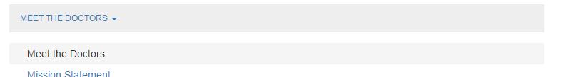

### Desktop View

**( NOT YET IMPLEMENTED )**

### Responsive View

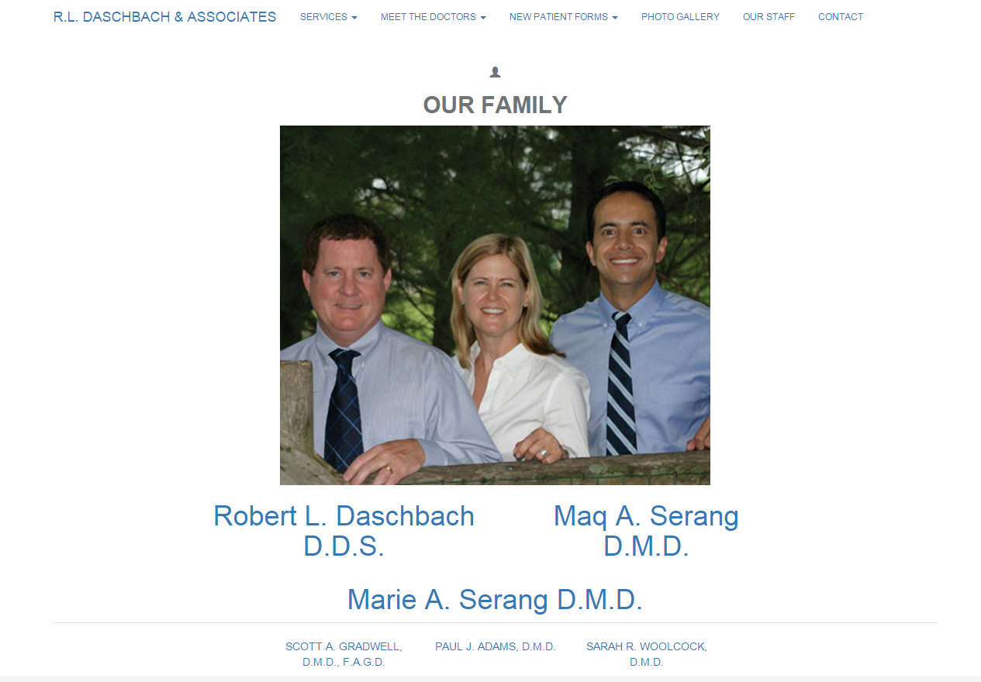

### Business Justification

Meet the Doctors allows us to put a face to a name. It brings personality to the website and gives information about the individuals who will be performing the work. It also helps to back up the personality of the business and the family-friendly feel of the office.

Doctor information will be displayed in a similar format for consistency. The most important aspect on this page is readability and access to doctor information. Pictures of each doctor will be shown in addition to a description.

Clickable links will be provided for navigation purposes.

Doctor information will be provided by the client in an external document.

The most important part of this page will be how the information is organized. It should be done in an attractive fashion that ultimately reduces the text on the page. It should also make sense to a user why the doctors and the office staff are separate pages.

### Technical Detail

The main doctor names are clickable and will scroll the user to the clicked portion of the page, with respect to the name that was clicked.

This page is mean to be organized in a fashion that makes sense. The current architecture is not final and should be viewed as a rough draft only to demonstrate what could be possible. Text will need to be rewritten by the client to reduce wordiness.

In coordination with modern design principles, information will be broken into large header text when possible. This is beneficial to the user by giving quick bullet pointed ideas of what information is given and beneficial to the office by reducing complexity of the information.

### Future Technical Implementation

* Reorganization of text
* Responsive imagery
* Font styling
* Page coloring
* Implementation of material design

### Client Approval

#### Reviewer Name:

#### Latest Review Date:

### Client Notes

|  |  |
| --- | --- |
| Review #: |  |
| Reviewer Date: |  |
| Review Name: |  |
| Reviewer Comments: |  |

## Mission Statement

Last Updated: 12/16/2015

The Mission Statement page can be accessed by clicking the Mission Statement menu in the navigation bar.

* <http://localhost:8069/Dashbach-Dentistry/mission_statement.php>

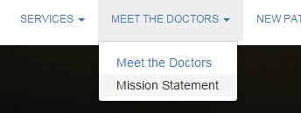

### Business Justification

Mission Statement is the doctor’s promise to those who work at the dentistry. It covers legal properties which give the office the ability to employ as a learning institution, among other concerns. The main purpose is in covering legal grounds for services which other offices would not be able to attend to.

This page should be clear in its purpose and in providing the information to those seeking employment or those who are currently employed.

### Technical Detail

The design of this page is currently not in accordance to the business requirements. As such, the current implementation should be disregarded for the moment.

### Client Approval

#### Reviewer Name:

#### Latest Review Date:

### Client Notes

|  |  |
| --- | --- |
| Review #: |  |
| Reviewer Date: |  |
| Review Name: |  |
| Reviewer Comments: |  |

## New Patient Forms

Last Updated: 12/16/2015

New Patient Forms do not have a page. They can be accessed at any time using the navigation bar menu titled ‘New Patient Forms’. When clicked, a pop-up will display and load the associated PDF documents.

* Hippa Form One
* Hippa Form Two
* Medical History Form
* Surgical Form

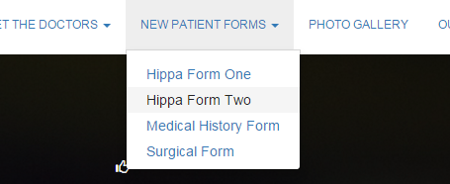

### Business Justification

Forms are important to the dental office for patient needs. They should be able to be displayed on all devices easily and be available on all pages of the website for ease of access. Download and print options should be available.

### Technical Detail

Modals are used to display PDFs. Scrolling is disabled while display is shown. Download and print options are not yet implemented.

### Client Approval

#### Reviewer Name:

#### Latest Review Date:

### Client Notes

|  |  |
| --- | --- |
| Review #: |  |
| Reviewer Date: |  |
| Review Name: |  |
| Reviewer Comments: |  |

## Photo Gallery

Last Updated: 12/16/2015

The Photo Gallery page can be accessed by clicking the ‘Photo Gallery’ link in the navigation bar.



* http://daschbachdentistry.gear.host/photo_gallery.php

### Business Justification

The photo gallery should be organized in a fashion that makes sense to the user and in a way that works with the pictures provided. It should showcase the office in a positive manner. This should be implemented in a photo gallery fashion that is already familiar to the standard user.

### Technical Detail

MixItUp is used for filtering and sorting. All pictures will be able to be updated via the Admin console (not yet implemented) for use by the dental office.

Initially, thumbnails are shown to act as picture preview. These will be low quality version of the picture to benefit users for load times. Clicking pictures brings up the gallery browser (modal) to view large versions of the thumbnails. The ‘next’ picture will be brought up the right arrow is clicked and ‘previous’ picture is brought up when the left arrow is clicked, similar to most software photo galleries (photo gallery moving is not yet implemented).

Filtering and sorting of the pictures is done via buttons at the top of the gallery.

### Desktop View

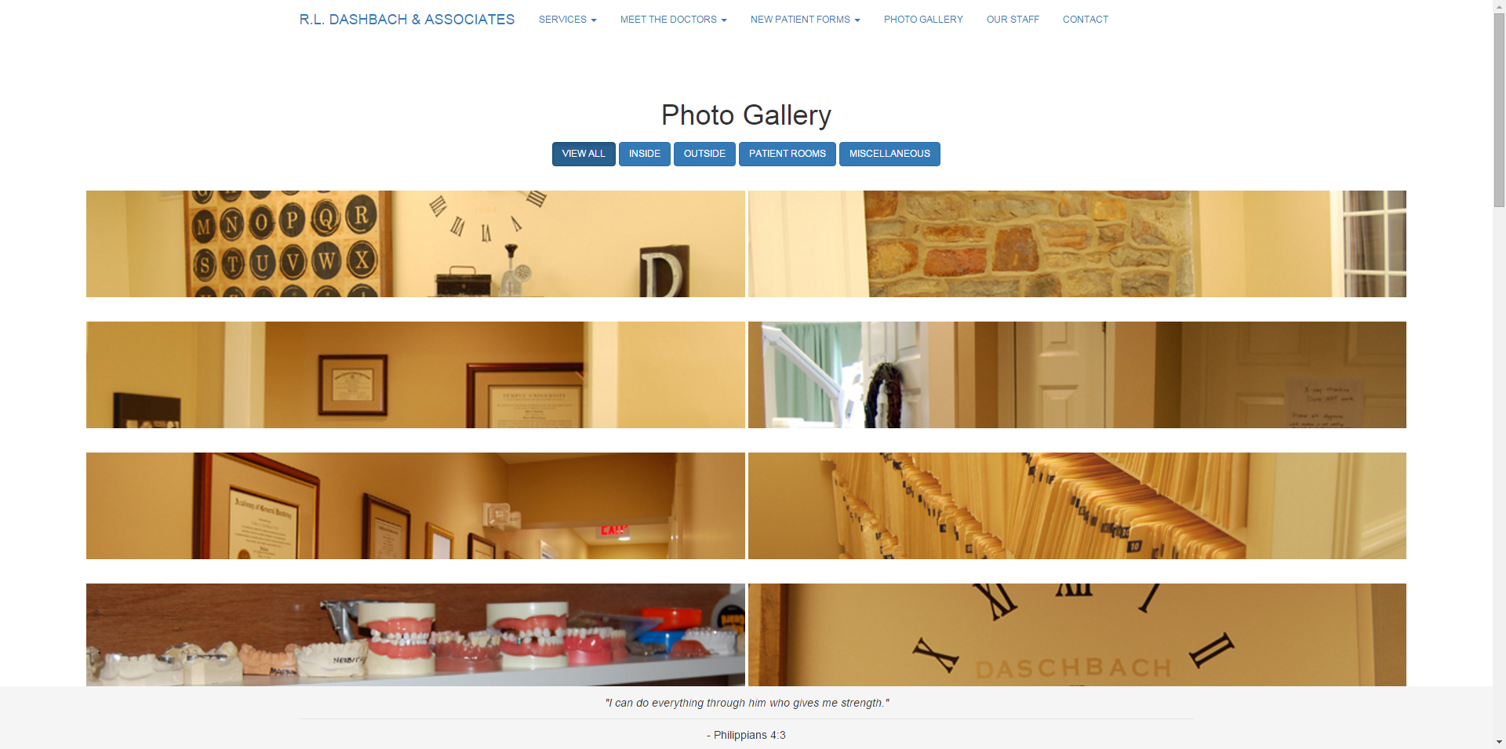

### Responsive View

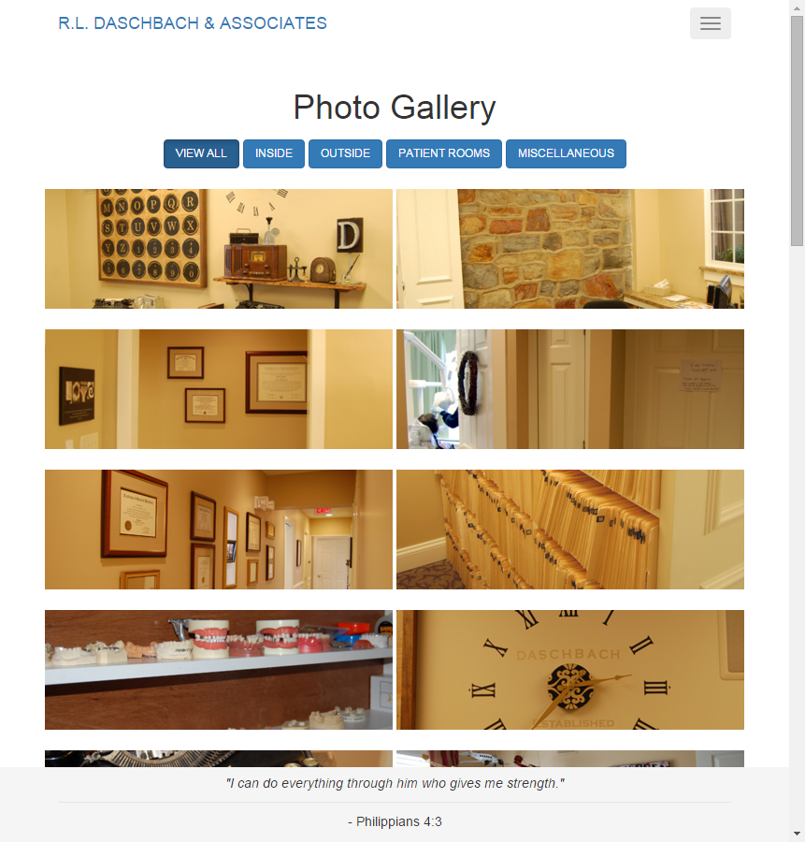

### Client Approval

#### Reviewer Name:

#### Latest Review Date:

### Client Notes

|  |  |
| --- | --- |
| Review #: |  |
| Reviewer Date: |  |
| Review Name: |  |
| Reviewer Comments: |  |

## Our Staff

Last Updated: 12/16/2015

The Our Staff page can be accessed by clicking the ‘Our Staff’ link in the navigation bar.



* http://daschbachdentistry.gear.host/our_staff.php

### Business Justification

This page showcases all of the other individuals at the dental office who choose to opt in to be on the website. A thumbnail preview of each person is initially shown and details about them can be obtained through manipulation of the page.

All details should be shown in a user friendly and organized fashion.

### Technical Detail

Page load is quick through low resolution images. Each image will require a black and white version, as well as a regular version. For this purpose, the free program Pixlr can be used to create the images quickly and easily by the client. A demo and documentation will be provided in the future.

Office staff is organized by general role in the office.

Clicking a picture scroll the user to the top of the page where details are shown of the person clicked. A colored version of the thumbnail is also shown, indicating the current person being detailed. Their role at the office is also displayed.

### Desktop View

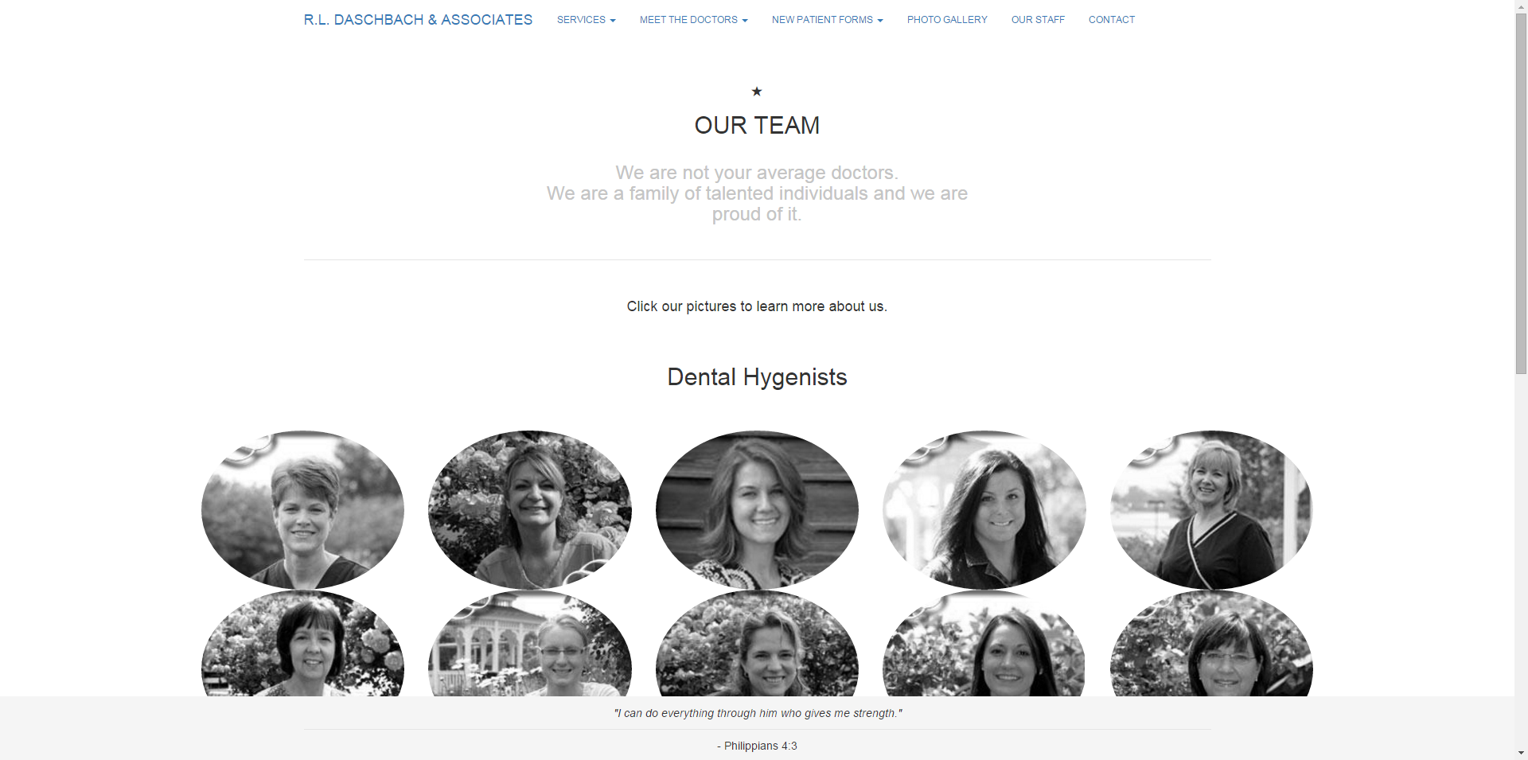

### Responsive View

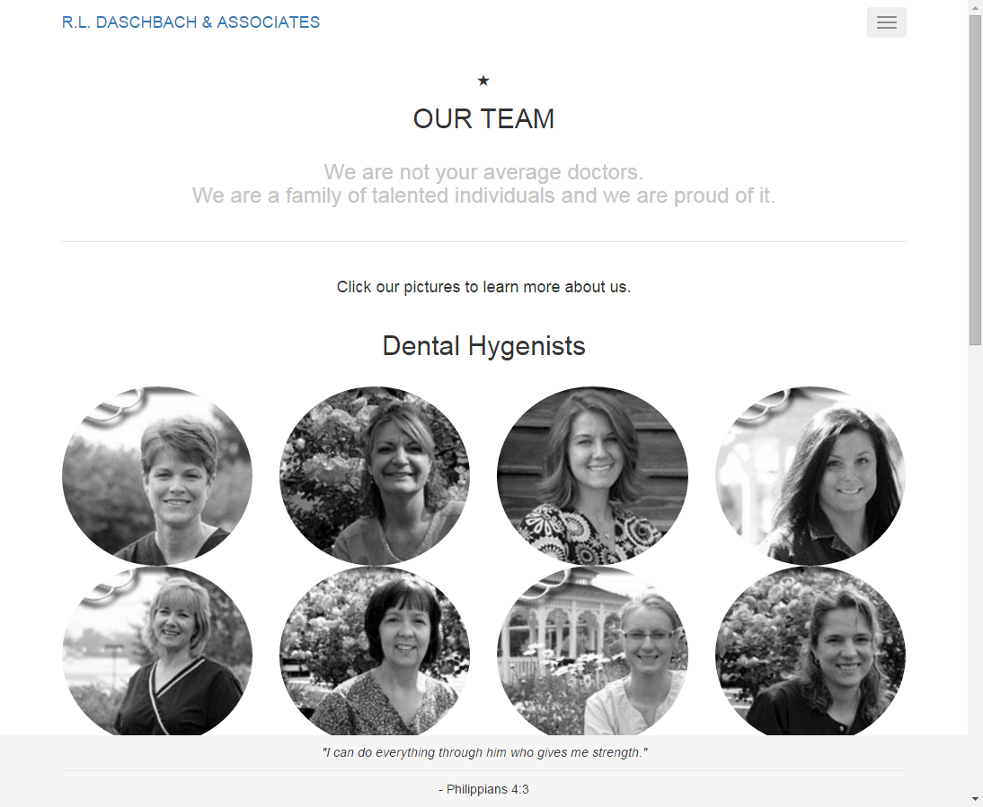

### Client Approval

#### Reviewer Name:

#### Latest Review Date:

### Client Notes

|  |  |
| --- | --- |
| Review #: |  |
| Reviewer Date: |  |
| Review Name: |  |
| Reviewer Comments: |  |

## Contact

Last Updated: 12/16/2015

The Contact page can be accessed by clicking the ‘Contact’ link in the navigation bar.



* http://daschbachdentistry.gear.host/contact.php

### Business Justification

Provide company contact details in an organized fashion. All information should be current, even for demo purposes.

### Technical Detail

Simple HTML/CSS page. Only technical detail worth making note is Google Maps integration. Possible Skype or other communication data can be implemented for future consideration.

### Desktop View

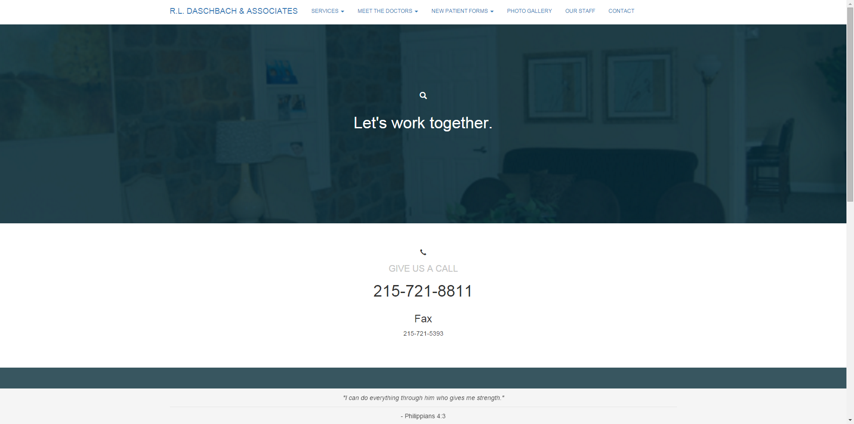

### Responsive View

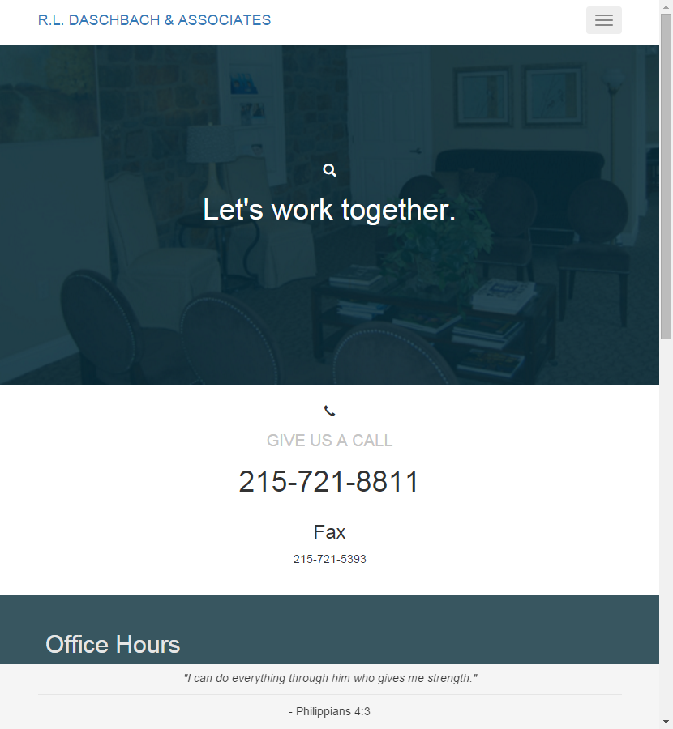

### Client Approval

#### Reviewer Name:

#### Latest Review Date:

### Client Notes

|  |  |
| --- | --- |
| Review #: |  |
| Reviewer Date: |  |
| Review Name: |  |
| Reviewer Comments: |  |

## Careers

Last Updated: 12/16/2015

**( NOT YET IMPLEMENTED )**

The Careers page can be accessed by clicking the ‘Careers’ link in the navigation bar. This page will contain information for current and future job offerings. Applications will be able to view information and submit an application via email to the provided address.

### Client Approval

#### Reviewer Name:

#### Latest Review Date:

### Client Notes

|  |  |
| --- | --- |
| Review #: |  |
| Reviewer Date: |  |
| Review Name: |  |
| Reviewer Comments: |  |

# Reporting Issues

Last Updated: 12/16/2015

## Taiga

Taiga is a bug reporting system. When issues with this site are identified, they must be recorded in Taiga. Taiga is open source, so it’s free. It is necessary as it provides clear issue identification for issues and allows us to scale our work as it becomes more complex, more projects develop or needs transpire over time.

### Using Taiga

#### Requesting an Account

Contact the system administrator and request access to Taiga. They will add you to the system and you can begin using Jira.

#### Accessing Taiga

Once access has been granted by the Taiga system administrator, Taiga can be accessed from the following URL: <https://tree.taiga.io>

Follow the login steps to create a password you’ll remember.

#### Reporting Issues

**( NOT YET IMPLEMENTED )**

## Load Times

Each page should load quickly to a user on all devices. Items which may reduce loading are documents, images and videos (if included). Improper website code could also introduce longer load times. When loads take longer than usual, clear the browser cache and reload the page. If the load can be confirmed to take an unusual amount of time on multiple occasions, it should be reported as an issue.

# Developer Notes

Last Updated: 12/16/2015

This section provides technical detail on information specific to future developers, such as technologies used, organization or structure of the website, and how to run the website locally.

## Technologies Used

Each web page file is in PHP for the sake of reducing repetitiveness in HTML for items such as nav bars and footers.

The pages themselves are designed for best use on modern web 2.0 browsers, but should also work with relatively older browsers.

### Included Technologies

* HTML5 / CSS3
  + Latest technologies where applicable
* JavaScript
  + Custom scripting
* Bootstrap
  + Row and column responsiveness for smaller screen width devices
  + Design patterns
* Font Awesome
  + Lightweight icon use and adaptation for responsiveness and minimal load
* Google Fonts
  + Fonts
* JQuery
  + JavaScript ease of use and animation
  + Required by Bootstrap
* MixItUp.js
  + Photo gallery organization, sorting, filtering and animation
* Google Material Design Patterns
  + Adhering to consistent design patterns oriented to the future

## Website Structure

**( NOT YET IMPLEMENTED )**

## Running Locally

**( NOT YET IMPLEMENTED )**

# Document History

|  |  |  |
| --- | --- | --- |
| Last Updated | Update Description | Updated By |
| 12/16/2015 | Created document | Ryan Piveteau |